SAVING SHAPIO
Game Jam Documentation
Softec Game Jam | Team: Game Jammers

2.5D Physics-Breaking Action Platformer | PC | Unity 6

Detail | Info
Genre | 2.5D Action Platformer
Platform | PC
Engine | Unity 6
Jam Theme | Broken Physics
Jam Name | Softec Game Jam
Dev Window | 4 Days
Team | Game Jammers
Status | Levels 1–5 complete. Boss level in progress.

Game Description
Saving Shapio is a 2.5D physics-breaking action platformer set in a neon-lit geometric world where the laws of physics are collapsing. The player controls a glowing Cube navigating increasingly chaotic levels, each ruled by a different enemy that bends physics in its own way.

The world — Shapio — is home to all geometric shapes. But something is wrong. Curves are vanishing. Platforms flicker. Forces pull and push where they have no right to. This isn't decay. It's design.

At the heart of the collapse is the Giant Cube; a corrupted behemoth systematically eliminating every curved shape from existence to remake Shapio in his own angular image. The player must fight through his chaos and stop him before nothing round remains.

Controls
Key | Action
A / D | Move Left / Right
Space | Jump
E | Dash (directional)
S + E | Downward Dash (attack / destroy core)
Wall contact | Wall Cling / Wall Climb

Health System
The player has 5 lives. There is no traditional health bar or UI. Health is communicated entirely through the visual glow of the player cube:

State | Visual
Full health | Cube glows at full neon brightness
Taking damage | Cube dims noticeably
Near death | Cube barely glowing, almost dark
Death | Cube light extinguishes, then shatters

Level Guide

Level 1 — Introduction
A beginner-friendly level designed to familiarise the player with all core movement and mechanics. The world intro voiceover plays here. No enemy. Players learn to move, jump, dash, wall climb, and cling before the physics start breaking.
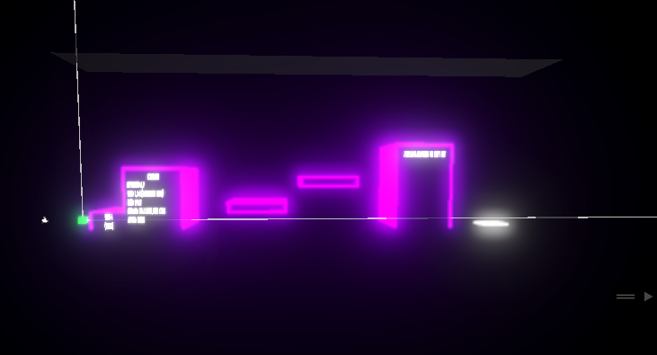

Level 2 — Moving Platforms & Light Platforms
Introduces two platform types that break the expectation of solid, stable ground. Moving platforms shift unpredictably across the level. Light platforms — made of solidified light — are visible and solid but dissolve if the player stands on them too long, dropping them into the void.
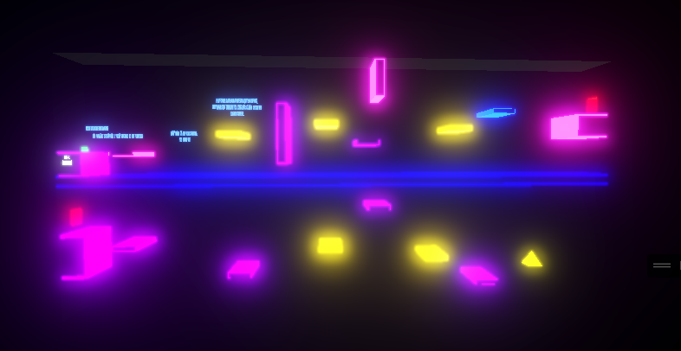

Level 3 — Curving Projectiles
The enemy Rectangulus fires projectiles that do not travel in straight lines. They curve mid-air and change trajectory unexpectedly, forcing the player to predict arcs rather than dodge in straight lines. Killed by dashing into it.
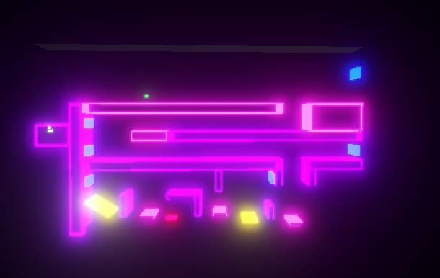

Level 4 — Corrupted Forces (Attraction & Repulsion)
The enemy Magnetus corrupts the forces of attraction and repulsion on surfaces throughout the level. Some surfaces pull the player inward and increase drag. Others repel the player away. Movement becomes unpredictable depending on which surface the player is near. Killed by dashing into it.
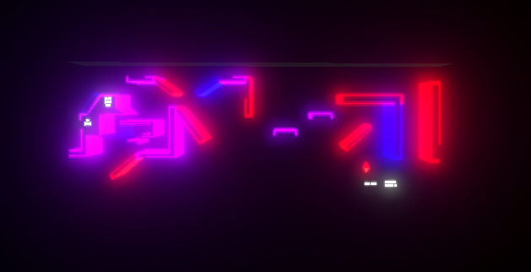
Level 5 — Inverted Controls
The enemy Trapezium inverts the player's left and right movement controls on entering the level. A and D are reversed for the entire level. The player must navigate and land a dash kill while disoriented. Killed by dashing into it.
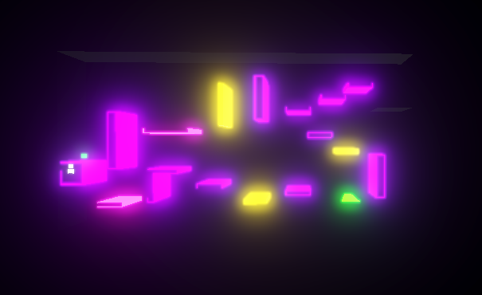

Level 6 — Boss Arena (The Giant Cube)
The final encounter. The Giant Cube combines all broken physics effects from previous levels simultaneously; curving projectiles, corrupted forces, inverted controls, dissolving platforms & moving platforms. He fires captured spheres and cylinders as projectiles and spawns 5 cores in the level. The player must destroy all 5 cores using a downward dash to defeat the Boss.
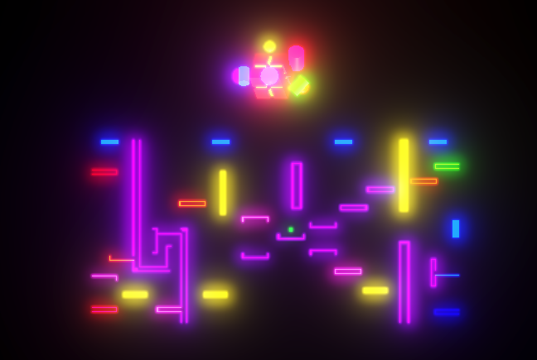

How to Run
- Extract the downloaded ZIP file to any folder
- Open the extracted folder and double-click SavingShapio.exe
- No installation required — the game runs directly
- Recommended resolution: 1920x1080 fullscreen
- PC only — Windows 10 or later

Known Issues & Notes
- The game is designed for keyboard only — controller not supported in this build

Development Team
Member | Role
Mustafa Qasim | 3D Modelling, Level Mechanics, Unity Implementation
Esha Nasir | Level Designer, Own Mechanics
Khairia Batool | Music, Sound Design, Own Mechanics

Softec Game Jam | Game Jammers | 2026

